الملحقات
الملحق الأول

تقييم بروتوكولات التوجيه الهرمية من حيث فعاليّة الطاقة وفق اعتبارات التجانس

Evaluation of WSN hierarchical routing protocols according to energy efficiency heterogeneity levels

Evaluation of WSN hierarchical routing protocols according to energy efficiency heterogeneity levels

Ahmad Al-Hilal¹ and Salah Dowaji2

Abstract: The hierarchical routing protocols of WSN depend on clustering algorithm to reduce energy consumption. Theses protocols can increase scalability and lifetime of the network. Energy-efficient clustering protocols should be designed for adapt to the characteristic of energy efficiency heterogeneity of wireless sensor networks.
In this paper, we evaluate hierarchical routing protocols by their sensitivity to energy heterogeneity and their effects on lifetime, number of cluster heads per rounds, performance, stability and instability period of the whole network.
The obtained simulation results show the comparison between three routing protocols designed to cop to different levels of energy heterogeneity. The first protocol (called LEACH) designed for homogeneous network , the second one (SEP) designed for tow-level heterogeneous networks and the third and last one (DEEC) designed for multi-level heterogeneous networks.
This paper shows which hierarchical routing protocol to use in sensor networks to cope with targeted performance measures taking into consideration application needs.

Keywords: Wireless sensor networks; Clustering algorithm; Heterogeneous environment; energy-efficiency.

Nomenclature
BS | Base station
CHs | Cluster heads
DT | Direct transmission
MTE | Minimum transmission energy
$E_{a}$ | Average of network energy
$E_{residual}$ | Node residual energy
Ē(r) | Average of network energy($E_{a}$)
Ei(r) | Node energy$(E_{residual})$
$E_{DA}$ | Data aggregation cost expended in cluster-heads
$d_{toBS}$ | Average distance between cluster-head and base station
$d_{toCH}$ | Average distance between cluster-head and its members
- Introduction
Wireless Sensor Networks are networks of tiny, battery powered sensor nodes with limited processing, storage and radio capabilities. Sensors sense the environment and send their data towards a processing centre called “Base Station or Sink” (BS). Designing routing protocols for such networks has to be energy-aware in order to prolong their lifetime; because the replacement of the embedded batteries is a very difficult once their nodes have been deployed [1-3].
A lot of protocols developed to be energy-efficient for such networks [2,3]. Theses protocols are classified into the following 4 categories:
  - Data-centric protocols:
We can’t use the traditional routing protocols which is address-based routing protocols, because it isn’t possible to use global addresses for network’s nodes. For this reason, some protocols were designed for selecting a set of sensors which can aggregate data and relay it to BS; such protocols are called data-centric protocols.
  - Hierarchical protocols:
Sometimes, we need more efficient protocols because sensors will not be able to send data for long distance and data-centric routing protocols lake of scalability when the application need a larger set of sensors to cover a wider region, so hierarchical protocols were designed to adapt extending the sensor network. The hierarchical protocols depend on clustering algorithms, such algorithms form clusters before data can be sent.
  - Location-based protocols:
There is no global addressing in sensor networks, and sensors maybe deployed randomly in the work field, so location information can be utilized to route data perfectly to the target. Protocols depending on such information are called location-based protocols.
  - Qos-based protocols:
Sometimes there are other considerations that should be taken into consideration in routing like end-to-end delay, maximizing lifetime or minimizing cost forwarding. Protocols taking such considerations into account are called Qos-based protocols.

In hierarchical protocols category, we can enumerate many of them. We will talk about some of these protocols into the following paragraphs.
A solution proposed in[4], called LEACH that is based on clustering algorithm, guarantees well distribution of energy consumption among the nodes of sensor network by dynamically electing cluster heads according to a prior optimal probability and consumes less energy than DT and MTE that don’t guarantee well balanced distribution of the energy among nodes of sensor network.
Currently, most of the clustering algorithms, such as LEACH [4], PEGASIS [8], and HEED [9], all assume that sensor networks are homogeneous networks. These algorithms perform poorly in heterogeneous environments. The low-energy nodes will die more quickly than the high-energy ones, because these clustering algorithms are unable to treat each node discriminatorily in term of the energy discrepancy. In [5], SEP scheme is proposed for the two-level heterogeneous wireless sensor networks, these networks contains types of nodes according
to the initial energy. The advance nodes are equipped
with more energy than the normal nodes at the beginning. SEP prolongs the stability period, which is defined as the time interval before the death of the first node. However, it is not fit for the widely used multi-level heterogeneous wireless sensor networks, which include more than two types of nodes. So the solution [6], called DEEC, this type of protocols treat each node discriminatorily in term of the energy discrepancy by rotating cluster head role among nodes according to the ratio between the residual energy of each node and the average energy of the network.
The solution proposed in [10], called EAP, it solves the heterogeneous energy problem by using E_{a} ÷ E_{residual} as primarily clustering parameter to elect cluster heads. So EAP can adapt better than other algorithms to heterogeneous energy circumstances.
In this paper, we evaluate the above following protocols: LEACH, SEP and DEEC to study their sensitivity feature to heterogeneity and compare their effects on lifetime, number of cluster heads per round, performance, stability and instability period of the sensor network.
- Studied protocols
The main task of sensor networks is sensing environment and transmitting sensed data to the base station (BS). A simple way to do this task is direct transmission (DT). In this case, each sensor in the network sends sensing data to the base station directly. However, if base station is far away from nodes, the node will die quickly due to excessive energy consumption for delivering data.
Hiezelman at el. [4] proposed an alternative clustering-based algorithm, called LEACH (Low-Energy Adaptive Clustering Hierarchy). It assumes that there exists a base station outside the sensor network and all the sensor nodes can communicate with it by passing through a selected node for each cluster called “Cluster Head” (CH). In order to save energy, LEACH uses probability p to serve as cluster heads (CHs) percent of all sensor nodes.
LEACH distributes energy consumption by rotating cluster heads among all nodes by dividing network operations into rounds.
Each round consists of two phases;
Set-up Phase
It consists of advertisement phase and cluster set-up phase.
Steady Phase
It consists also of schedule creation and data transmission.

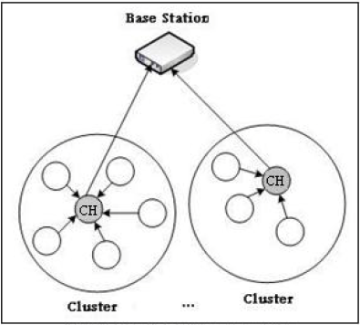
Fig (1). LEACH Structure
After cluster formation phase, the cluster heads aggregate received data from its members and send them to the base station by single hop communication, so it can sharply reduce packets needed to be transmitted to the base station, this means that less energy required.
The decision for a node to become a CH is made at the beginning of each round by each node s Є G independently choosing a random number in [0,1] (G is a set contains non-elected nodes as cluster heads in last epoch and the probability for these nodes increases after each round in the same epoch).
If the random number is less than a threshold T(s) then the node become a cluster head in the current round.
The threshold is set as:
$$T\left(s\right)=\left\{\begin{aligned}\frac{Popt}{1-Popt(r mod \frac{1}{Popt})} if s∈G \\ 0 otherwise \end{aligned}\right\} (1)$$

Where r is the current round, Popt is the fraction p determined before deployment, G is a set contains non-elected nodes as cluster heads in last epoch and the probability for these nodes increases after each round in the same epoch.
G. Smaragdakis, I. Matta, A. Bestavros [5] proposed a new approach that assigns a weight to the optimal probability Popt. This weight must be equal to the initial energy of each node divided by the initial energy of the normal node. It defines Pnrm the weighted election probability for normal nodes and Padv the weighted election probability for the advanced nodes.

$$Pnrm= \frac{Popt}{\begin{aligned}1+a.m \\ \end{aligned}}$$
$(2)$
$$Padv= \frac{Popt}{\begin{aligned}1+a.m \\ \end{aligned}} ×(1+a)$$
By replacing Popt by the weighted probability to obtain the thresholds required for new approach elections, we have:
$$T\left(Snrm\right)=\left\{\begin{aligned}\frac{Pnrm}{1-Pnrm(r mod \frac{1}{Pnrm})} if Snrm∈G' \\ 0 otherwise \end{aligned}\right\} (3)$$
$$T\left(Sadv\right)=\left\{\begin{aligned}\frac{Padv}{1-Padv(r mod \frac{1}{Padv})} if Sadv∈G" \\ 0 otherwise \end{aligned}\right\} (4)$$

Where r the current round, G’ is the set of nodes haven’t elected as CHs throw last 1/pnrm rounds of the epoch, G” is the set of nodes haven’t elected as CHs throw last 1/padv rounds of the epoch.

Li Qing, Qingxin Zhu, Mingwen Wang. [6] proposed a DEEC protocol which uses initial and residual energy level of the nodes to select the cluster-heads.
DEEC assigns a probability Pi for each node and this probability changes from round to another, this means the probability adapts changes in the energy of the network nodes. This probability Pi calculated based on residual energy of node Ei(r) and average energy Ē(r) at round r, we have:
$$Pi=Popt\left[1-\frac{Ē\left(r\right)- Ei\left(r\right) }{Ē\left(r\right)}\right]=Popt \frac{ Ei\left(r\right) }{Ē\left(r\right)} (5)$$

Each node Si uses threshold T(Si) to determine whether it will be a CH in each round, as follow:

$$T\left(Si\right)=\left\{\begin{aligned}\frac{Pi}{1-Pi(r mod \frac{1}{Pi})} if Si∈G \\ 0 otherwise \end{aligned}\right\} (6)$$
Where G is a set contains non-elected nodes Si as CHs during most recent ni rounds, so Si Є G.
The average energy Ē(r) which is used as reference energy is calculated in DEEC is follow:
$$Ē\left(r\right)= \frac{1}{N} E_{total }\left(1-\frac{r}{R}\right) (7)$$
Where R calculated as follow:

$$R= \frac{E_{total}}{E_{round}} (8)$$
$$E_{round}=L\left(2NE_{elec}+NE_{DA} +kε_{mp}{d_{toBS}^{4}}^{ }+Nε_{fs}d_{toCH}^{2} \right), (9)$$

Where k is the number of cluster, EDA is the data aggregation cost expended in the CHs, d_{toBS} is the average distance between the CH and the BS, and d_{toCH} is the average distance between CH and its members.
In [7], M. Bani Yassein, A. Al-zou'bi, Y. Khamayseh, W. Mardini suggest a new version of LEACH as an improvement on LEACH protocol called VLEACH which aims to reduce energy consumption in wireless sensor networks. They have studied LEACH protocol and suggested an enhanced version of it, and proposed that the cluster should contains, CH (responsible only for sending data that is received from the cluster members to the BS) and vice-CH (the node that will become a CH of the cluster in case of CH dies) and cluster nodes (gathering data from environment and send it to the CH), the function of vice-CH is to take the role of CH when the CH dies.
In [8] S. Lindsey et al proposed an algorithm called PEGASIS, nodes will be organized to form a chain based on GREED algorithm as follow:
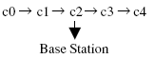
This algorithm outperform LEACH especially when the energy consumed for receiving or sending circuits is higher than that consumed for amplifying circuits, this happens when the distance between sensor network and sink node is far large.

In [9], HEED is a distributed clustering algorithm, which selects the cluster-heads randomly. The election probability of each node is correlative to the residual energy. But in heterogeneous environments, the low-energy nodes could own smaller probability to elect nodes comparing to the high-energy nodes in HEED.
In [10] Ming Liu, Jiannong Cao, Guihai Chen and Xiaomin Wang proposed an algorithm called EAP, each node holds a neighbors table similar to the following one:
ID | State | Residual Energy (J)a
3 | Candidate | 1.32J
7 | Candidate | 0.16J
6 | Candidate | 0.09J
5 | Candidate | 0.32J

EAP uses rounds and phases like LEACH, each node receives messages from its neighbors in cluster rang and updates its neighbors table. EAP uses E_{a} ÷ E_{residual} as the primarily clustering parameter for competing cluster heads, where E_{a} denotes the average residual energy of the cluster range of the node.

- Research work
We evaluate energy efficiency for hierarchical routing protocols by selecting three protocols differing one from each other by heterogeneity level that we take it into account.
3.1. Research protocols:
Our research is focused on studying the following protocols: LEACH, SEP and DEEC from the above mentioned protocols.
3.2. Research cases:
In our evaluation we compare performance of selected protocols based-on measures specified in section 3.3, by using three different sensor network types as specified in the following simulation cases:
1st case (homogeneous network)
The energy of every node in such network is determined as follow:
${Ei =E}_{0}$, where i: 1 N
This means that the total energy is:
$$E_{total} =NE_{0} (10)$$

2nd case (tow-level heterogeneous network)
In the tow-level heterogeneous networks, there are two types of sensor nodes, i.e., the advanced nodes and normal nodes.
The energy of the normal nodes E0, but advanced nodes own a timed more energy than normal nodes. m is the fraction of advanced nodes among the total number of nodes in the network. Thus there are mN advanced nodes equipped with initial energy of E0 (1+ a), and (1 – m) normal nodes equipped with initial energy of E0. The total energy of the two-level heterogeneous networks is calculated as follow:
$$E_{total} =N\left(1-m\right)E_{0}+ NmE_{0}\left(1+a\right)=)tal olscult once there NE_{0}\left( 1+am\right). (11)$$
Thus the two-level heterogeneous networks have am time more energy than homogeneous networks. This means having virtually am more nodes.
3rd case (m-level heterogeneous network)
In multi-level heterogeneous networks, initial energy of sensor nodes is randomly distributed over the close set [E0, E0(1 + a_{max})], where a_{max} determine the value of the maximal energy. Initially, the node s_{i} is equipped with initial energy of E0(1 + a_{i}), which is a_{i} times more energy than the lower bound E0. The total initial energy of multi-level heterogeneous networks is calculated as follow:
$$E_{total}= \sum_{i=1}^{N}{E_{0}\left(1+a_{i}\right)= E_{0}\left(N+\sum_{i=1}^{N}{a_{i}}\right) (12) }$$
3.3. Performance measures and simulation Environment:
We define here the measures we use in this paper to evaluate the performance of clustering protocols.
• Stability Period: is the time interval from the start of network operation until the death of the first sensor node. We also refer to this period as “stable region.”
• Instability Period: is the time interval from the death of the first node until the death of the last sensor node. We also refer to this period as “unstable region.”
• Network lifetime: is the time interval from the start of operation (of the sensor network) until the death of the last alive node.
• Number of cluster heads per round: This instantaneous measure reflects the number of nodes which would send directly to the sink information aggregated from their cluster members.
• Number of alive (total, advanced and normal) nodes per round:
This instantaneous measure reflects the total number of nodes of each type that haven’t yet expended all of their energy.

To assess the performance of the selected three routing protocols , we simulated their performance measures using Matlab and compared their performance with each other by applying these protocols on three kind of networks: homogeneous (deploying nodes with same energy), two-level heterogeneous (deploying nodes with two types of energy), multi-level heterogeneous (deploying nodes different in their energy).

Table 1
Parameters used in simulations
Parameter | Value
E_{elect} | 5 nJ/bit
Ԑ_{mp} | 10 pJ/bit/m²
Ԑ_{fs} | 0.0013 pJ/bit/m⁴
E₀ | 0.5 J
E_{DA} | 5 nJ/bit/message
d₀ | 70 m
P_{opt} | 0.5
Message size | 4000 bits

Table 2
Extra parameters used in two-level heterogeneous networks simulations
Parameter | Description | Value
m | Advanced nodes percentage | 0.1
a | Extra energy percentage | 1

Table 3
Parameters used to define deployment
Parameter | Description | Value
LxL | Dimension of work field | 100mX100m
N | No. of nodes | 100

- Simulation results
We show in the following sections the obtained simulation results for each performance measures in each case.
4.1. Network lifetime & Number of alive nodes measures
1st case (homogeneous network)
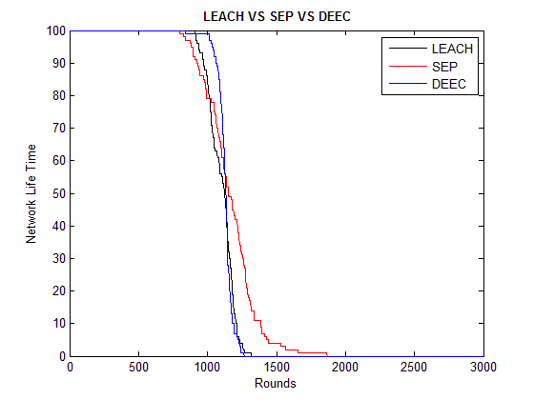
Fig (2). lifetime & number of alive nodes in homogeneous network
Figure (2) shows that first node died at round 796 in SEP, whereas in LEACH, it died at round 909, and at round 841 In DEEC. The explanation for that is that rotating cluster heads among nodes in SEP isn’t efficient in homogeneous networks. But both LEACH and DEEC are more efficient in rotating CHs. The figure also shows that that last node died at round 1876 in SEP, whereas in LEACH, it died at round 1320, and at round 1265 in DEEC, but still the network in SEP has the greatest lifetime, this means that SEP instable when applied on homogeneous networks. As we see, network in DEEC has the smallest network lifetime.
2nd case (tow-level heterogeneous network)
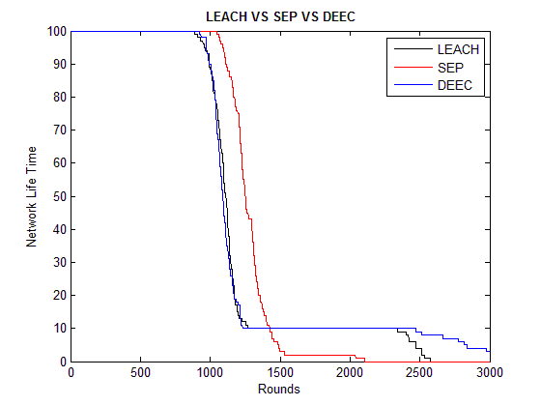
Fig (3). lifetime & number of alive nodes in two-level heterogeneous network
Figure (3) shows that first node died at round 891 in LEACH, whereas in SEP, it died at round 1050, and at round 925 In DEEC. The explanation for that is rotating cluster heads among nodes in LEACH isn’t efficient in two-level heterogeneous networks. But both SEP and DEEC are efficient in rotating CHs. The figure also shows that last node died at round 2108 in SEP, whereas in LEACH, it died at round 2574, and at round after 3000 in DEEC, but SEP is stable more than DEEC and LEACH, because the figure shows that there are just one or two nodes still alive in SEP, whereas there are still 10 nodes alive in both DEEC and LEACH, this number (10) is equal to the percentage of advanced nodes from total nodes.
3rd case (m-level heterogeneous network):
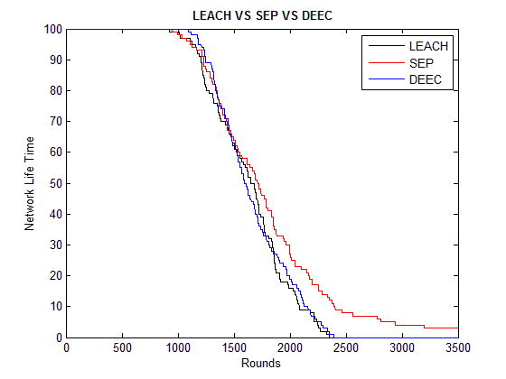
Fig (4). lifetime & number of alive nodes in multi-level heterogeneous network
Figure (4) shows that first node died at round 927 in LEACH, whereas in SEP, it died at round 952, and at round 1090 In DEEC. The explanation for that is rotating cluster heads among nodes in SEP isn’t efficient in multi-level heterogeneous networks, and LEACH is more efficient than SEP, whereas DEEC is the most efficient in rotating CHs. The figure also shows that that last node dies (not displayed on the chart for SEP) at round after 3500, whereas in LEACH, it died at round 2351, and at round 2390 in DEEC. The network in SEP has the greatest lifetime, this means that SEP unstable when applied on multi-level heterogeneous networks. As we see, network in LEACH has the smallest network lifetime.

4.2. Stability period measure
1st case (homogeneous network)
Figure(2) shows that LEACH has the greatest period from starting network operations (round 0) until dying the first node (round 909) in the network, this means that LEACH has the greatest stability period, then DEEC, and the last one is SEP which has the smallest stability period. These results guide us to use LEACH in homogeneous networks deployed for applications that need more stability period.
2nd case (tow-level heterogeneous network)
Figure (3) shows that SEP has the greatest period from starting network operations (round 0) until dying the first node (round 1050) in the network, this means that SEP has the greatest stability period, then we see DEEC because it takes heterogeneity into its account, and the last one is LEACH which has the smallest stability period because it doesn’t takes the heterogeneity into account. These results guide us to use SEP in two-level heterogeneous networks deployed for applications that need more stability period.
3rd case (multi-level heterogeneous network)
Figure (4) shows that DEEC has the greatest stability period, from round number 0 to round number 1090, because it is more efficient in multi-level heterogeneous network, followed by SEP (round 0 to round 952 ) which deals two types of nodes, and the last one is LEACH (round 0 to round 927) which has the smallest stability period.
4.3. Instability period measure
1st case (homogeneous network)
Figure (2) shows that LEACH has the smallest period between dying the first node (round 909) and dying the last one (round 1320) in the network, this means that LEACH has the smallest instability period, then DEEC (from round 841to round 1265) has instability period near that in DEEC, and the last one is SEP (from round 796 to round 1876) which has the largest instability period.
2nd case (tow-level heterogeneous network)
In figure (3), SEP has the smallest period between dying the first node (round# 1050) and dying the last one (round# 2108) in the network, this means that SEP has the smallest instability period. The figure shows also that from round# 900 until round# 2300, the number of still alive nodes is 10 which represents the percentage of advanced nodes from the total nodes, this yields large instability period in both DEEC and LEACH.
3rd case (multi-level heterogeneous network)
In figure (4), DEEC has instability period from round# 1090 to round#2390, and LEACH has instability period from round# 927 to round#2351, and SEP has instability period from round# 952 to round after 3500. These results guide us that DEEC has the smallest instability period, this can be explained by saying that DEEC works well with n-level heterogeneous networks, and LEACH has instability period near to that in DEEC, whereas SEP has the largest one.

4.4. Throughput measure
1st case (homogeneous network)
The figure (5) shows the total packets sent from non-CH nodes to CH nodes. As we see in the figure that DEEC has packets to send to CHs less than LEACH, and SEP.
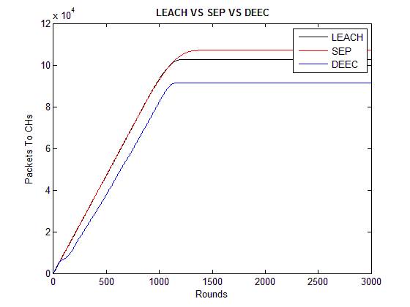
Fig (5). Packets to CHs in homogeneous network.
The figure (6) shows the total packets sent from CH nodes to BS. As we see in the figure, DEEC has packets to send to BS greater than LEACH, and the last one is greater than SEP (unlike results in figure(5)), but the packets sent to BS in DEEC is very high, this due to the number of elected cluster heads per round in DEEC is greater than other protocols.
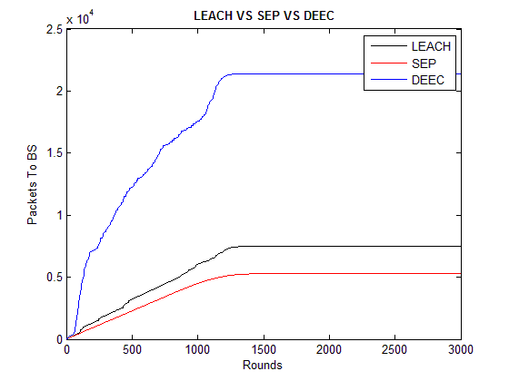
Fig (6). Packets to BS in homogeneous network
The figure (7) shows the total packets sent to both CHs and BS which called throughput. Throughput of DEEC is greater than SEP, and SEP is greater than LEACH. We can see that SEP is near DEEC. This explained that the throughput of protocols taking heterogeneity into account is better than those not doing so.

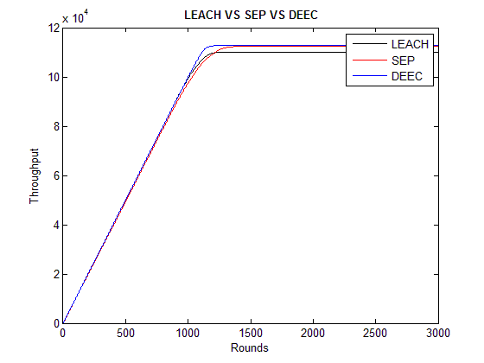
Fig (7). Total Throughput in homogeneous network
2nd case (tow-level heterogeneous network)
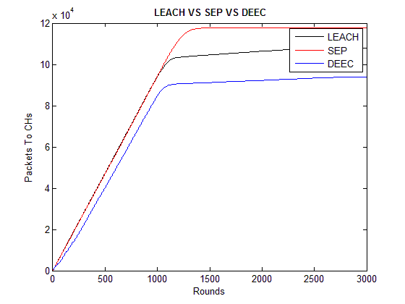
Fig (8). Packets to CHs in two-level heterogeneous network
Figure (8) shows the same results we showed in figure(5), but we clearly see that the packets sent to CHs in SEP is greater than those in figure (5), and the explanation for that is SEP generates more packets in two-level heterogeneous environments.
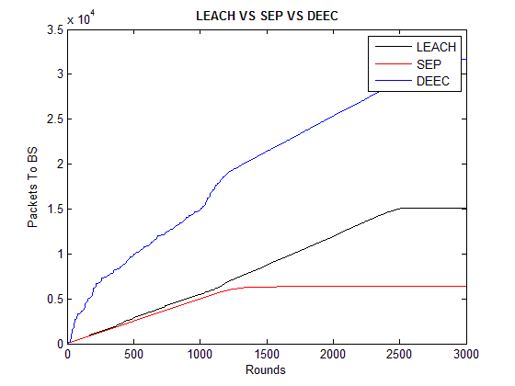
Fig (9). Packets to BS in two-level heterogeneous network
The figure (9) shows the total packets sent from CH nodes to BS. As we see in the figure, DEEC has packets to send to BS greater than LEACH, LEACH is greater than SEP. We can explain that (unlike results in figure(8), but the packets sent to BS in DEEC is very high, this due to the number of elected cluster heads per round in DEEC which is greater than other protocols.
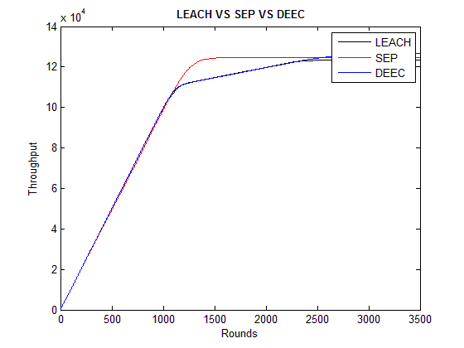
Fig (10). Total Throughput in two-level heterogeneous network.
In figure (10), throughput of LEACH is similar to that in both DEEC and SEP until round 1000, and then SEP differs from round 1000 to the end of simulation time, but still LEACH similar to that in DEEC until round 2500, and then they differ from round 2500 to the end of simulation time. At the end of simulation, it is clear that DEEC has the best throughput, then SEP and the last one is LEACH.
3rd case (multi-level heterogeneous network)
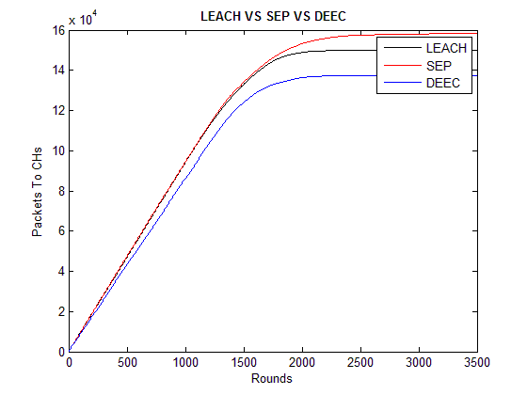
Fig (11). Packets to CHs in multi-level heterogeneous network
The figure (11) shows that the total packets sent from non-CH nodes to CH nodes is close to that in both cases homogeneous and two-level heterogeneous networks, but it is clear here that traffic movement is a little bit different.
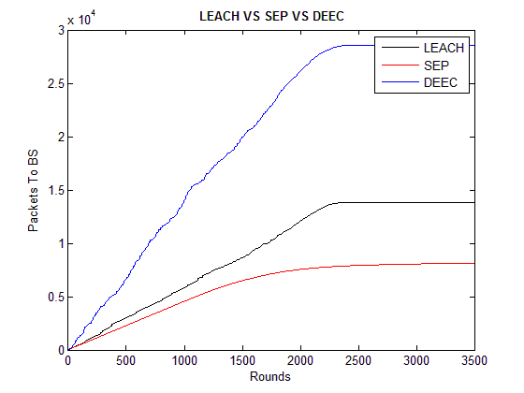
Fig (12). Packets to BS in multi-level heterogeneous network.
The figure (12) shows that the total packets sent from CHs nodes to BS is close to that in both cases homogeneous and two-level heterogeneous networks, but it is clear here that traffic movement is also a little bit different.
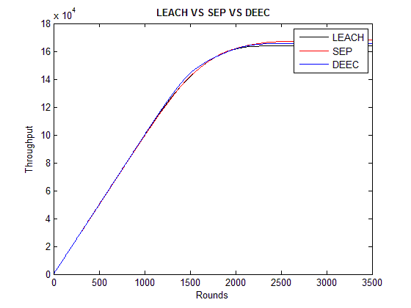
Fig (13). Total Throughput in multi-level heterogeneous network.
In figure (13), throughput of the three protocols is similar, but in the end of the simulation, it is clear that SEP has the most better throughput, then DEEC and the last one is LEACH.

4.5. Number of cluster heads per round measure
1st case (homogeneous network)
In figure (14), the cluster heads percent for LEACH is centred around 5%, and the figure shows that the election ends at round# 1320 which is round# of last dead node. Whereas for SEP, cluster heads percent is also centred around 5% until round 1300, and then this percentage goes down until the end of the elections at round# 1876. Finally for DEEC, there is a variance in cluster heads percentage, because it moves up to near 40%, and down to near 0%, and the election ends at round# 1265 which is round# of the last dead node.
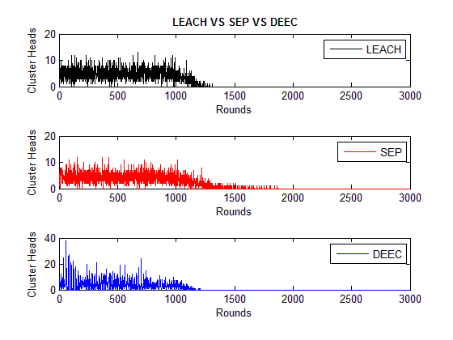
Fig (14). number of CHs in homogeneous network
2nd case (tow-level heterogeneous network)
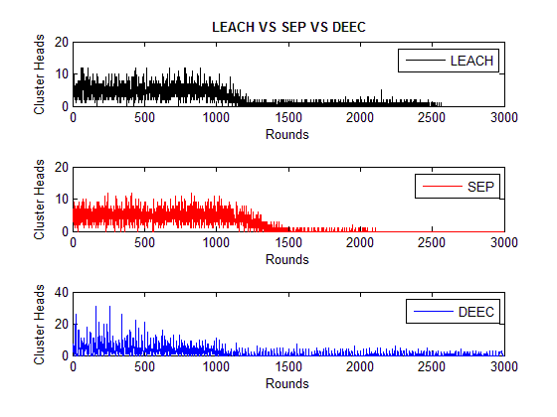
Fig (15). number of CHs in two-level heterogeneous network.
In figure (15), there is a clear difference from figure (14) related to the case of homogeneous network. There is some variance in cluster heads percentage for LEACH which is almost centred around 5% until rounds near 1200, and from after round# 1200 until round# 2574 (death of last node). So, it is centred around 1% which represents cluster heads percentage of still alive nodes (advanced node). Whereas for SEP, cluster heads percent is also centred around 5% with some clear variance until round 1300, and then this percentage goes down until the end of the elections at round# 2108. Finally for DEEC, there is a variance in cluster heads percentage, because it moves up to near 30%, and goes down to close 1%, and the elections continue going on after the end of the simulation, because there are still alive nodes.

3rd case (multi-level heterogeneous network)
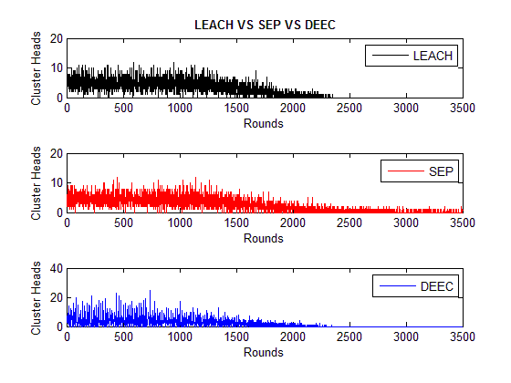
Fig (16). number of CHs in multi-level heterogeneous network.

In figure (16), the cluster heads percent for LEACH is centred around 5%, and the figure shows that the election ends at round# 2351 which is round# of last dead node. Whereas for SEP, cluster heads percent is also centred around 5% until round 2000, and then this percentage goes down, and the elections continue going on after the end of the simulation time. Finally for DEEC, there is a variance in cluster heads percentage, because it moves up to near 20%, and goes down to near 1%, and the election ends at round# 2390 which is round# of last dead node.
- Conclusion
The ultimate objective of this paper is to show which hierarchical routing protocol to use in sensor networks to cope with targeted performance measures.

Table 4 summarizes obtained results by using the studied protocols: LEACH, SEP and DEEC with in three types of sensor networks (homogenous, two-level heterogeneous and multi-level heterogeneous networks), and we arrange the results by the priority of each performance measure.

Table 4
 | Homogenous | 2-level  Heterogeneous | Multi-level  Heterogeneous
Stability period  (crucial for many applications where the feedback from  the sensor network must be reliable ,so the longer value is preferred) | LEACH & DEEC yield to long measure value (preferred).  SEP yields to small measure value. | SEP has the greatest measure value (preferred).  LEACH & DEEC have the smallest measure value. | DEEC yields to the longest measure value (preferred).  LEACH yields to long measure value if there is a little bit difference between nodes’ energy.  SEP yields to the smallest measure value.
Instability period  the smaller value is the preferred value | LEACH & DEEC yield to small measure value (preferred).  SEP yields to long one. | LEACH & DEEC yields to long measure value.  SEP yields to small measure value (preferred). | DEEC yields to small measure value (preferred).  LEACH yields to small measure value if there is a little bit difference between nodes’ energy.  SEP yields to long measure value.
Total throughput  the longer value is preferred | SEP & DEEC have the largest throughput (preferred).  LEACH has the smallest throughput. | DEEC has the longest throughput (preferred).  SEP has less throughput comparing to DEEC.  LEACH has the smallest throughput. | SEP has the longest throughput (preferred).  DEEC has throughput less than SEP.  LEACH has the smallest throughput.
Lifetime  the longer value is preferred in the case of no need for reliability | LEACH & DEEC yield to small lifetime (preferred if reliability not necessary).  SEP yields to long lifetime. | LEACH & DEEC yield to long lifetime.  SEP yields to small lifetime (preferred if reliability not necessary). | DEEC yields to small measure value.  LEACH yields to long measure value if there is a little bit difference between nodes’ energy.  SEP yields to long measure value (preferred if reliability not necessary).
No. Of CHs  (optimal value is N*$P_{opt}$) | In LEACH, it is centred around optimal value (preferred).  SEP, it isn’t centred around optimal value during instability period (long period).  DEEC, there is a variance in it. | In LEACH & SEP, it is centred around optimal value during stability period,  but in SEP, CHs percentage is centred around optimal value which is the optimal value. This percentage extends along the stability period which is the best measure value for SEP protocol  (SEP preferred).  DEEC, there is a variance in it. | In LEACH, it is centred around optimal value (preferred).  SEP, it isn’t centred around optimal value during instability period (long period).  DEEC, there is a variance in it.

This study helps us to make decision which one fits to our application needs before deploying the sensors in the work field. For example many applications need reliability to insure the feedback from sensor nodes, some applications need to prolong the

lifetime of sensor batteries because of difficulty of recharge or replace them.

References
- I.F. Akyildiz, W. Su, Y. Sankarasubramaniam, E.Cayirci, Wireless sensor networks: a survey, Computer Networks, Elsevier, Vol. 38, pp. 393–422, 2002.
- K.Akkaya, M.Younis, A survey on routing protocols for wireless sensor networks, Ad Hoc Networks, Vol. 3, No.3, pp. 325-349, 26 November 2003.
- Al-Karaki, Jamal N, Routing Techniques in Wireless Sensor Networks: A Survey, Wireless Communications, IEEE, pp. 6-28, Dec 2004.
- W. R. Heinzelman, A. P. Chandrakasan, and H. Balakrishnan, An application-specific protocol architecture for wireless microsensor networks, IEEE Transactions on Wireless Communications, Vol 1, No. 4, pp. 660–670, October 2002.
- G. Smaragdakis, I. Matta, A. Bestavros, SEP: A Stable Election Protocol for clustered heterogeneous wireless sensor networks, Second International Workshop on Sensor and Actor Network Protocols and Applications (SANPA 2004), 2004.
- Li Qing, Qingxin Zhu, Mingwen Wang, Design of distributed energy-efficient clustering algorithm for heterogeneous wireless sensor networks, Computer Communications, Vol. 29, No. 12, pp. 2230–2237, 10 March2006.
- M. Bani Yassein, A. Al-zou'bi, Y. Khamayseh, W. Mardini, Improvement on LEACH Protocol of wireless Sensor Network(VLEACH), International Journal of Digital Content Technology and its Applications, Vol. 3, n. 2, pp. 132-136, June 2009.
- S. Lindsey, C.S. Raghavenda, PEGASIS: power efficient gathering in sensor information systems, in: Proceeding of the IEEE Aerospace Conference, Big Sky, Montana, Vol. 3, pp. 9-16, March 2002.

- O. Younis, S. Fahmy, HEED: A hybrid, energy-efficient, distributed clustering approach for ad hoc sensor networks, IEEE Transactions on Mobile Computing, Vol. 3, No. 4, pp. 660–669, Oct.-Dec. 2004.
- M. Liu, J. Cao, G. Chen and X. Wang, An Energy-Aware Routing Protocols in Wireless Sensor Networks, Sensors, Vol. 9, pp. 445-462, 2009.


1 Ahmad ALHILAL is a master student at Information Technology Engineering Faculty, Damascus University. He had born in Syria, Dar’a at 1985-01-03. He holds Bachelor degree in computer engineering from Information Technology Engineering Faculty at Damascus University in Syria, 2008. He is a senior java developer and an assistant-teacher at Information Technology Engineering Faculty, Damascus University. He has more than 2 years of experience in planning, projects development and administration of Linux servers. He has also more than 2 years of teaching practical courses about network application programming, programming language, and network security at Damascus University.


2 Salah DOWAJI received his Engineering degree in Information Technology from Higher Institute of Applied Sciences and Technology in Damascus, Syria, and the PhD degree in parallel programming from Pierre et Marie Curie University (Paris VI University), Paris, France in 1995. He is now an associated professor at Information Technology Engineering Faculty, Damascus University. His research interests include parallel processing, networking, distributed and cloud computing.

الملحقات
الملحق الثاني

تحسين بروتوكول LEACH ليتكيّـف مع بعد الحساسات عن المحطة الأساسية

Base Station Distance Adaptive LEACH

تحسين بروتوكول LEACH ليتكيّـف مع بعد الحساسات عن المحطة الأساسية
م.أحمد الهلال¹ ,أ. د. صلاح الدوه جي²

طالب ماجستير – قسم النظم والشبكات الحاسوبية، كلية الهندسة المعلوماتية, جامعة دمشق, سوريا¹
أستاذ مساعد, كلية الهندسة المعلوماتية, جامعة دمشق, سوريا²

الملخص:

تحتاج بعض التطبيقات لنشر حساسات في حقل العمل لتقوم هذه الحساسات بتحسُّس البيئة وتوجيه المعطيات المحسوسة إلى المحطة الأساسية حيث ستعالج هذه المعطيات. هذه الحساسات تعتمد على بطاريات غير قابلة للشحن, لذلك فإنَّ خورازميات التوجيه المقترحة لشبكة الحساسات هذه يجب أن تكون فعّالة للطاقة. أحد البروتوكولات المقترحة لهذه الشبكات هو بروتوكول التوجيه الهرمي LEACH الذي يساعد على توفير الطاقة ويتكيّف مع الطاقة المنخفضة في هذه الحساسات.

سنقوم في هذا البحث بدراسة شبكات الحساسات المتجانسة و تحسين بروتوكول LEACH (الذي يعمل في الأساس بكفاءة وينتج أداء عالي في هذا النوع من الشبكات) ليتكيّف مع البعد عن المحطة الأساسية, وبالتالي توفير أكثر في الطاقة من أجل أبعاد معينة للحساسات عن المحطة الأساسية.

ستوضِّح نتائج المحاكاة بأنَّ بروتوكول LEACH المُحسَّن يعطي أداء أفضل من LEACH وذلك من أجل الحالات التي تكون فيها المحطة الأساسية ضمن حقل العمل, ويتساوى مع أداء LEACH من أجل الحالات التي تكون فيها المحطة الأساسية خارج حقل العمل.

الكلمات المفتاحية: شبكات الحساسات اللاسلكية, البيئة المتجانسة, فعاليِّة الطاقة, بروتوكولات التوجيه الهرميّة.

- المقدمة:
تُعتبر شبكات الحساسات من التقنيات الحديثة في عالم التكنولوجيا، تتيح هذه الشبكات طيف واسع من التطبيقات الجديدة المتمثلة بربط منظومات التحكم والمراقبة بالعالم الحقيقي عن طريق نشر حساسات قريبة من الظاهرة أو الحدث قيد الدراسة، وتقوم هذه الحساسات بجمع المعطيات و إرسالها إلى مركز اتخاذ القرار،الذي يقوم بدوره بتحليلها ومن ثم اتخاذ القرار المناسب.
وتعرَّف شبكات الحساسات اللاسلكية على أنَّها مجموعة من العقد الحساسة التي تتصل مع بعضها لاسلكياً دون الحاجة إلى بنية تحتية وتعتمد على بطارية لتزويدها بالطاقة, ومن أهم وظائفها استشعار الوسط المحيط ونقل المعطيات المحسوسة عن طريق عقد تمرير أو بدونها إلى العقدة الوجهة, كما هو وارد في المراجع
]2-4[.
تتميز شبكات الحساسات اللاسلكية بمحدودية موارد العقد المكونة لها من حيث مدى الإرسال وعرض الحزمة المتاحة وقدرة هذه العقد على المعالجة والتخزين، بالإضافة إلى محدودية موارد الطاقة التي تغذِّي هذه العقد حيث أنَّها تكون بطارية غير قابلة لإعادة الشحن أو التبديل في معظم الحالات.
  - تطبيقات هذه الشبكات :
- مراقبة البيئة
- تطبيقات عسكرية: الكشف عن الهجمات البيولوجية والكيميائية ومراقبة ساحة المعركة.
- تطبيقات صناعية : مراقبة خطوط الانتاج وضبطها في الاماكن التي يصعب وصول الانسان إليها.
- تطبيقات طبية : رصد البيانات الفيزيولوجية البشرية عن بعد.
- تطبيقات البيت الذكي : بيئة ذكية.

2.1. أنواع بروتوكولات التوجيه:
قدَّمت الأبحاث ]3,4[ تصنيف لبروتوكولات التوجيه في شبكات الحساسات اللاسلكية حسب الأنواع التالية :
- التوجيه المسطّح (Flat routing):
تعتمد على استعلامات تُنشأ من قبل المحطة الأساسية ومن ثم تُنشر عبر الشبكة.
- التوجيه الهرمي (Hierarchical routing):
تقوم بتقسيم الشبكة إلى مجموعة من العناقيد، وتتعامل مع نوعين من العقد، النوع الأول العقد العادية التي تقوم بمهام الاستشعار للوسط، والنوع الثاني عقد تعمل رؤوساً للعناقيد تقوم بمعالجة البيانات ضمن الشبكة و إرسالها إلى الوجهة, وهناك عدة بروتوكولات مستخدمة ومحققة في هذا النطاق:
- : LEACHخوارزمية توجيه هرمية تعتمد على العناقيد للتكيُّف مع الطاقة المنخفضة.
- PEGASIS :فعالية الطاقة جمع المعلومات في أنظمة الإستشعار[8].
- TEEN : خوارزمية توجيه هرمية فعّالة بالنسبة للطاقة وحسّاسة للعتبة.
- التوجيه المعتمد على موقع العقد (Location based routing):
يتم الإعتماد على معلومات مواقع العقد بهدف نقل المعطيات عبر الشبكة باتجاه العقدة الوجهة.
- التوجيه المعتمد على جودة الخدمة (QOS based routing ):
تأخذ بعين الإعتبار مثلاً زمن التأخير طرف-طرف عند بناء المسارات في شبكة الحساسات اللاسلكية.

3.1. النموذج الراديوي لتحليل الطاقة:
سنعتبر نموذج راديوي بسيط من أجل تبدد الطاقة من عتاديات الأشعة الراديوية , حيث أنّ المرسل يبدد الطاقة لتشغيل الالكترونيات الراديوية ومضخم الطاقة والمستقبل يبدد طاقة لتشغيل الإلكترونيات الراديوية كما في الشكل (1) .
يمكن استخدام كلاً من نموذجي القنوات كطريقة لفقدان الطاقة :
- فقدان الطاقة في حال فضاء حر ($d^{2}$ ) .
- فقدان الطاقة في حال تخامد متعدد المسارات ( $d^{4}$ ).
يمكن استخدام متحكم طاقة لإختيار أحد نماذج القنوات السابقة وذلك بإعداد مناسب لمضخم الطاقة :
- إذا كان البعد بين المرسل والمستقبل أقل من عتبة $d_{0}$ عندها يُستخدم نموذج الفضاء الحر.
- وإلا يُستخدم نموذج التخامد متعدد المستويات.
تستهلك الأشعة الراديوية بالنسبة لرسالة مؤلفة من k بت والبعد d مايلي :
طاقة الإرسال :
وهو الشكل المبسَّط لطاقة الإرسال على مسافات قريبة , أما الشكل العام فهو :
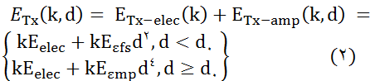

حيث k عدد بتات الرسالة , d مسافة الإرسال , $E_{elec}$الطاقة الإلكترونية, $E_{εmp}$ طاقة التضخيم.
طاقة الإستقبال:
تستهلك الأشعة الراديوية طاقة لإستقبال الرسالة كالتالي :
$$E_{Tx}\left(k,d\right)= kE_{elec } (3)$$
الشكل ( 1 ) الإرسال والإستقبال في الحساسات
طاقة الإلكترونيات $E_{elec}$ تعتمد على عوامل مثل الترميز الرقمي , التعديل , الفلترة و توسيع الإشارة . بينما يعتمد مضخم الطاقة $ε_{mp}d^{4} أو ε_{fs}d^{2}$ على المسافة إلى المرسل ومعدل خطأ ترميز مقبول.
الطاقة المستهلكة في رأس العنقود:
يستهلك رأس العنقود طاقة لإستقبال الإشارات من العقد , تجميع الإشارات ونقل الإشارة المجمّعة إلى المحطة الأساسية .
بما أن المحطة الأساسية بعيدة عن العقد , نعتبر مسبقاً أنّ الطاقة المبدّدة تتبع نموذج التخامد متعدد المسارات $d^{4}$.
وبناءاً على ذلك فإنّ الطاقة المبددة في رأس العنقود أثناء إطار زمني واحد هي :
$E_{CH}=kE_{elec}\left(\frac{N}{k}-1\right)+kE_{DA}\frac{N}{K}+$ $kε_{mp}d_{toBS}^{4} \left(4\right)$
حيث $d_{toBS}^{ }$ هو البعد بين رأس العنقود والمحطة الأساسية ونفترض تجميع معطيات تام.
الطاقة المستهلكة في العقد غير الرأسية:
تحتاج كل عقدة غير رأسية لنقل معطياتها إلى رأس العنقود فقط مرة كل إطار , يفترض مسبقاً أنّ البعد إلى رأس العنقود صغير , لذلك فالطاقة المبدّدة تستخدم نموذج فقد طاقة $d^{2}$ فضاء حر , لذلك فالطاقة المستخدمة في هذه العقد :
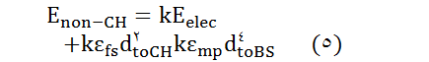

حيث $d_{toCH}^{ }$ هو البعد من العقدة إلى رأس العنقود , كل عنقود يحتل مساحة تساوي تقريباً ${M^{2}}/k$.
سندرس من هذه الخوارزميات فقط الخوارزميات الهرمية وبالذات بروتوكول التوجيه الهرمي LEACH ونقوم بالتحسين على هذا البروتوكول.
- محتوى البحث:
قدّم البحث [1] الذي اقترحه الباحثان A. Al-Hilal, S. Dowaji تقييم لأداء بروتوكولات التوجيه الهرمية حسب مستوى التجانس والذي استنتج الباحثان من خلاله بأنَّ بروتوكول التوجيه الهرمي LEACH هو البروتوكول الأكثر فعاليّة من حيث أدائه في شبكة الحساسات اللاسلكية المتجانسة, لذلك سينطلق هذا البحث من هذا البروتوكول ويحاول التحسين عليه بحيث نحصل على أداء أعلى للشبكة (دورة حياة, فترة استقرار, فترة عدم استقرار), وسنستخدم هذا البروتوكول للمقارنة مع البروتوكول الذي سينتجه البحث.

1.2. بروتوكول LEACH :

كما هو وارد في المرجع [5], اقترح الباحثان W. R. Heinzelman, A. P. Chandrakasan بروتوكول LEACH والذي يعتمد في انتخابه لرؤوس العناقيد على عتبة تُحسب وفق العلاقة التالية:
$T\left(s\right)=\left\{\begin{aligned}\frac{Popt}{1-Popt(r mod \frac{1}{Popt})} if s∈G \\ 0 otherwise \end{aligned}\right\} (6)$
حيث r تمثل الجولة الحالية, Popt هي الإحتمالية الأمثلية التي يتم انتخاب رؤوس العناقيد وفقها, G هي مجموعة العقد التي لم تُنتخب رؤوساً للعناقيد في آخر epoch واحتمالية هذه العقد تزداد بعد كل جولة في نفس epoch .
يقوم بروتوكول LEACH باختيار رقم عشوائي ضمن المجال [0,1], فإذا كان الرقم أصغر من العتبة عندها يتم اختيار العقدة كرأس للعنقود.

2.2. بروتوكول LEACH المتكيّف للبعد عن المحطة الأساسية:

تُحسب العتبة في هذا البروتوكول على غرار تلك التي في بروتوكول LEACH وفق العلاقة (6), ولكنه لايعتمد فقط على هذه العتبة لإنتخاب رأس العنقود, حيث أنه يعتمد أيضاً على معدل طاقة الشبكة وبالتالي فإنه يستخدم للإنتخاب مايلي:

يقوم أيضاً باختيار رقم عشوائي ضمن المجال [0,1], فإذا كان الرقم أصغر من العتبة عندها يختبر الشرط الثاني.
- طاقة العقدة أكبر من معدل طاقة الشبكة المقدّرة.
نظرياً, يمكننا حساب الطاقة الوسطية للشبكة (معدل طاقة الشبكة) في الجولة رقم (i) كالتالي :
حساب الطاقة الوسطية في الجولة رقم (i) = مجموع طاقات العقد في الجولة رقم (i) مقسوماً على عدد العقد الحية, وهي تُعبِّر عن الطاقة الوسطية الحقيقة للشبكة. فعلياً لا يمكننا حساب هذه القيمة في كل عقدة لأنَّها تتطلب معرفة طاقة باقي العقد في الشبكة وطبعاً هذا صعب ويولِّد عبء على الشبكة واستهلاك أكبر في طاقة العقد, و لتجنب ذلك سنلجأ إلى تقدير معدل طاقة الشبكة كما اقترحها الباحثون Li Qing, Qingxin Zhu, Mingwen Wang في المرجع [6].

تقدير معدل طاقة الشبكة:
تقوم كل عقدة بحساب طاقة الشبكة الكلية وفق العلاقة التالية: ${ E}_{total} =NE_{0} \left(7\right)$
تنطلق كل عقدة في حساب الطاقة الكلية من كون الشبكة متجانسة وبالتالي كل العقد تمتلك نفس الطاقة لإبتدائية ${ E}_{0}$ثم تقوم كل عقدة بتقدير معدل طاقة الشبكة دون الحاجة إلى معرفة طاقة بقية العقد حسب العلاقة التالية:
$Ē\left(r\right)=\frac{1}{N} E_{total }\left(1-\frac{r}{R}\right) \left(8\right)$
حيث R هو عدد الدورات الأعظمي الذي يمكن أن تستغرقها عمليات الشبكة ويتم حسابها وفق العلاقة التالية:
$R= \frac{E_{total}}{E_{round}} \left(9\right)$
حيث يتم حساب الطاقة المستهلكة في كل جولة وفق العلاقة التالية:
${ E}_{round}=L\left(2NE_{elec}+NE_{DA} +kε_{mp}{d_{toBS}^{4}}^{ }+ Nε_{fs}d_{toCH}^{2} \right) \left(10\right)$
حيث N هو عدد عقد الشبكة, $E_{elec}$ هي طاقة الإرسال, $E_{DA}$ هي الطاقة المستهلكة لتجميع المعطيات في رؤوس العناقيد, $d_{toBS}^{ }$ تمثل وسطي البعد مابين رأس العنقود والمحطة الأساسية, $d_{toCH}^{ }$ وسطي البعد مابين رأس العنقود وأعضائه.

حساب بعد المحطة الأساسية عن حقل العمل:
يتم حساب بعد المحطة الأساسية عن حقل العمل كالتالي:
يتم أولاً حساب عتبة البعد والتي بناءاً عليها نقرر فيما إذا كانت المحطة الأساسية خارج حقل العمل أو ضمنه وفق العلاقة التالية:
$d_{th}= \sqrt{\frac{Ԑ_{fs}}{Ԑ_{mp}}} \left(11\right)$
حيث $E_{fs}$ هي الطاقة اللازمة لتضخيم طاقة الإرسال في حال استخدام النموذج الراديوي في فضاء حر, و$E_{mp}$ هي الطاقة اللازمة لتضخيم طاقة الإرسال في حال استخدام النموذج الراديوي في فضاء متعدد المسارات, ثم يتم حساب بعد العقدة عن المحطة الأساسية وفق المعادلة التالية:
${BS}_{distance}= \sqrt{{\left(S\left(i\right).x-Sink.x\right)}^{2}+{(S\left(i\right).y-Sink.y)}^{2}} \left(12\right)$
ثم يتم مقارنة بعد العقدة عن المحطة الأساسية ${BS}_{distance}$ مع عتبة البعد $d_{0}$ لمعرفة الطريقة التي سوف تستخدم في إنتخاب رؤوس العناقيد.
وبالتالي يمكننا تحديد فيما إذا كانت العقدة داخل أم خارج حقل العمل, فإذا كانت المحطة الأساسية خارج حقل العمل عندها يتم تطبيق منطق خوارزمية LEACH التقليدية للإنتخاب وإلا يتم تطبيق منطق خوارزمية LEACH المُحسّنة لهذا الإنتخاب.
.3.2.2 المخطط التدفقي لخوارزمية LEACH المُحسّنة:
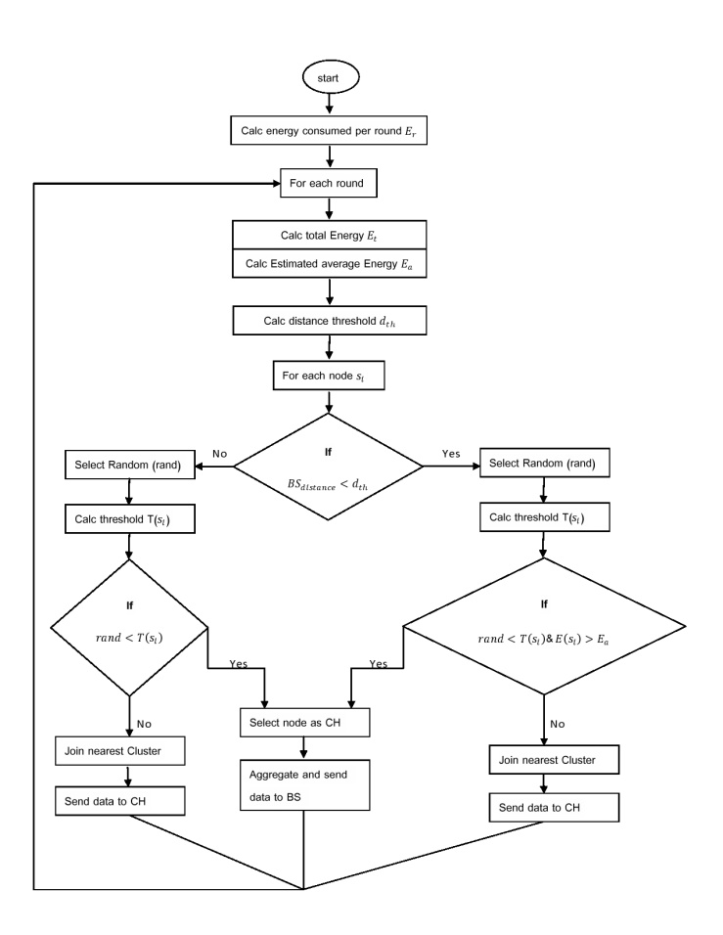
الشكل ( 2 ) مخطط تدفقي لخوارزمية LEACH المُحسّنة

فتكون الخوارزمية الناتجة (pseudo Code) بالشكل التالي :
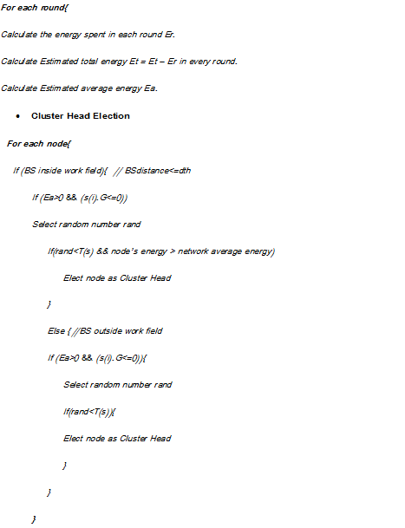
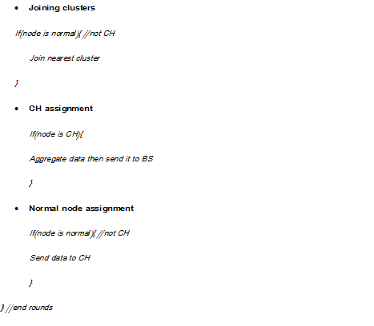

الشكل ( 3 ) pseudo Code لخوارزمية LEACH المُحسّنة

- بارامترات المحاكاة:
سوف نستخدم برنامج Matlab كوسيلة للمحاكاة والمقارنة بين بروتوكول LEACH و LEACH المحسَّن, حيث سيتم تطبيق كل منهما على شبكة تمَّ نشر عقدها بشكل عشوائي باستخدام تابع rand لتحديد إحداثيات كل عقدة من العقد, وسنرى في الجدول التالي الوسطاء المستخدمة في المحاكاة:

الباراميتر | معناه | القيمة
E_{elect} | طاقة الكترونيات الإرسال والإستقبال | 5 nJ/bit
Ԑ_{mp} | طاقة نموذج تعدد المسارات | 10 pJ/bit/m²
Ԑ_{fs} | طاقة نموذج الفضاء الخالي | 0.0013 pJ/bit/m⁴
E_{o} | الطاقة الابتدائية | 0.5 J
E_{DA} | طاقة التضخيم | 5 nJ/bit/message
d_{o} | عتبة البعد | 70 m
P_{opt} | الاحتمال الأمثلي | 0.05
K | حجم الرسالة | 4000 bits
n | عدد العقد | 100
الجدول (1) برمترات المحاكاة والمقارنة
- مقارنة بين بروتوكول LEACH و بروتوكول LEACH المُحسّن:
سندرس حالتين من موقع المحطة الأساسية عن شبكة الحساسات المتجانسة وهما:

1.4. الحالة الأولى : المحطة الأساسية ضمن حقل العمل
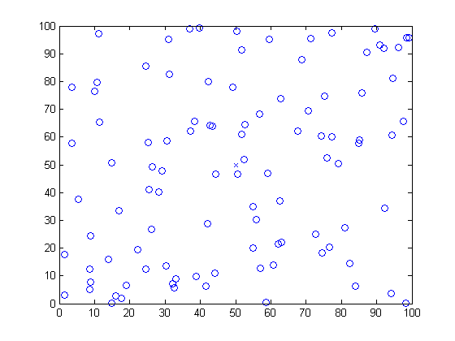
الشكل (4) نشر العقد وتموضع BS في وسط حقل العمل
يوضح الشكل (4) تموضع العقد في الشبكة والتي تم نشرها بشكل عشوائي, وتتموضع المحطة الأساسية ضمن الشبكة, حيث لو فرضنا أنّه تمّ نشر العقد على مساحة 100*100 فإنّ تموضع المحطة الأساسية تكون بالنقطة (50,50) أي في منتصف الحقل.
سنقارن بين البروتوكولين حسب مقاييس الأداء التي ذكرها الباحثون G. Smaragdakis, I. Matta, A. Bestavros في المرجع [7].
    - دورة حياة الشبكة:
هي الوقت الفاصل بين بدء عمليات الشبكة وحتى موت آخر عقدة حية.
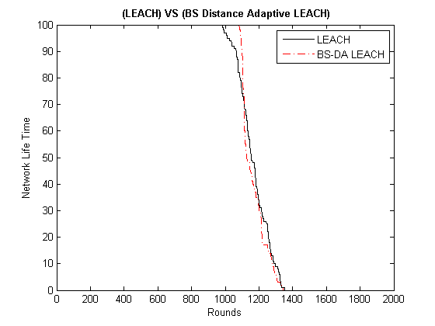
الشكل (5) مقارنة دورة حياة الشبكة بين LEACH و LEACH المحسّن

نلاحظ من المخطط (5) أنَّ دورة حياة الشبكة في LEACH تتماثل مع تلك التي في LEACH المحسّنة وهذا المقياس ليس بالضرورة أن يكون مفيد, لأنّه بعض التطبيقات تحتاج لأن تكون التغذية الراجعة من العقد موثوقة, ودورة حياة الشبكة الطويل ليس مفيد إلَّا اذا اقتُرنَ بفترة استقرار أطول.
    - فترة الاستقرار:
وهي الوقت الفاصل بين بدء عمليات الشبكة حتى موت أول عقدة,وتدعى أيضاً منطقة الاستقرار .
نلاحظ من الشكل (5) أنّ فترة الاستقرار في LEACH المحسَّن أكبر منها في LEACH في حال كون المحطة الأساسية ضمن الشبكة, وبالتالي فإنّ بروتوكول LEACH المحسّن يعطي أداء أفضل من أجل مقياس فترة الاستقرار.
    - فترة عدم الاستقرار:
تُعرَّف بأنها الفترة مابين موت أول عقدة وآخر عقدة , و هذا المقياس ضروري للتطبيقات التي تحتاج إلى وثوقية عالية عند إرسال تقارير (تغذية راجعة) من شبكة الحساسات.
نلاحظ من الشكل (5) أنّ فترة عدم الاستقرار في LEACH المحسّن أصغر منها في LEACH, وبالتالي يُعتبر LEACH المحسّن البروتوكول الأنسب للتطبيقات التي تحتاج لوثوقية.
    - الإنتاجية :
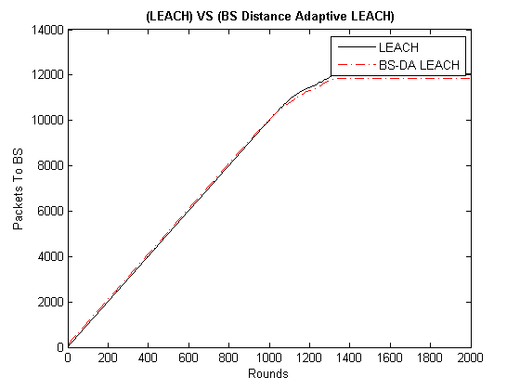
الشكل (6) عدد الطرود المُرسلة إلى المحطة الأساسية
نلاحظ من الشكل (6) أنّ إنتاجية LEACH المُحسَّن من حيث عدد الطرود المُرسلة إلى المحطة الأساسية أصغر بقليل منها في LEACH (تفاوت بسيط بين انتاجيتي البروتوكولين). 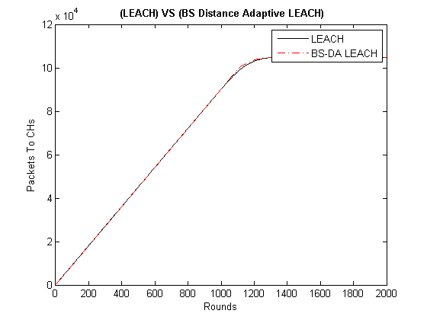
الشكل (7) عدد الطرود المُرسلة إلى رؤوس العناقيد
نلاحظ من الشكل (7) أنّ إنتاجية LEACH المُحسَّن من حيث عدد الطرود المُرسلة إلى رؤوس العناقيد تتطابق مع انتاجيّة LEACH وذلك في حال كون المحطة الأساسية ضمن الشبكة.
    - عدد رؤوس العناقيد في كل جولة:
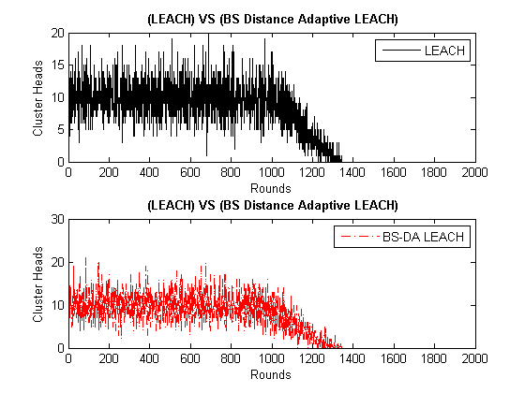
الشكل (8) عدد رؤوس العناقيد بكل جولة
نلاحظ تطابق عدد رؤوس العناقيد في كل جولة في كل من LEACH وLEACH المحسّن وذلك حسب المخطط (8).

2.4. الحالة الثانية : المحطة الأساسية خارج حقل العمل
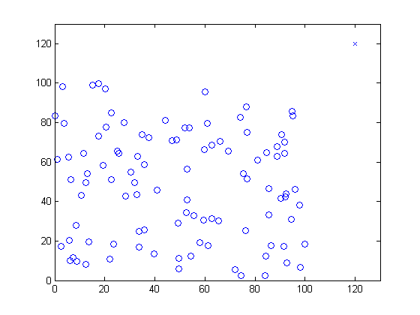
الشكل (9) نشر العقد وتموضع BS في النقطة (120,120)

يوضح الشكل (9) تموضع العقد في الشبكة والتي تم نشرها بشكل عشوائي, وتتموضع المحطة الأساسية خارج الشبكة, حيث لو فرضنا أنّه تمّ نشر العقد على مساحة 100*100 فإنّ توضُّع المحطة الأساسية تكون بالنقطة (120,120) .
1.2.4. دورة حياة الشبكة:
هي الوقت الفاصل بين بدء عمليات الشبكة وحتى موت آخر عقدة حية.
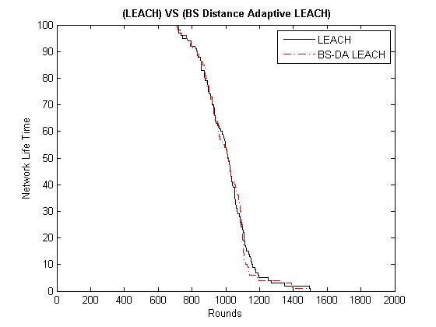
الشكل (10) مقارنة دورة حياة الشبكة بين LEACH و LEACH المحسّن
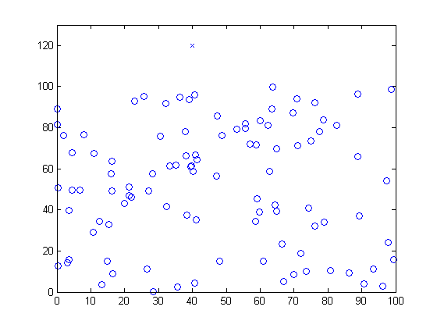
الشكل (11) نشر العقد وتموضع BS في النقطة (40,120)
يوضح الشكل (11) تموضع العقد في الشبكة والتي تم نشرها بشكل عشوائي, وتتموضع المحطة الأساسية خارج الشبكة, حيث لو فرضنا أنّه تمّ نشر العقد على مساحة 100*100 فإنّ تموضع المحطة الأساسية تكون بالنقطة (40,120) .
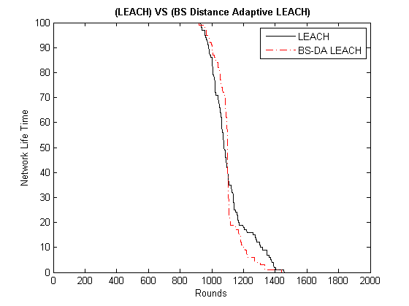
الشكل (12) مقارنة دورة حياة الشبكة بين LEACH و LEACH المحسّن
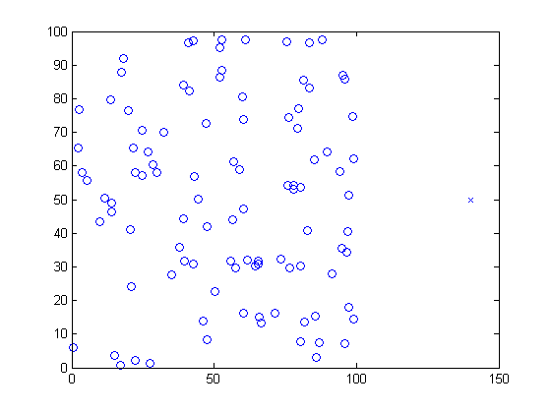
الشكل (13) نشر العقد وتموضع BS في النقطة (140,50)
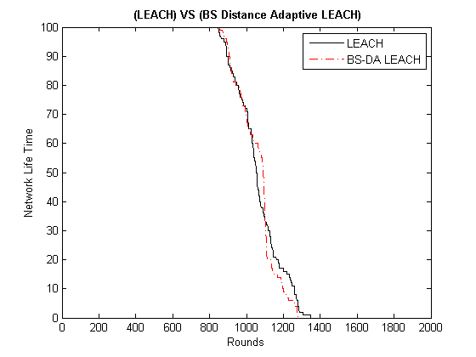
الشكل (14) مقارنة دورة حياة الشبكة بين LEACH و LEACH المحسّن

نلاحظ من الأشكال (10)(12)(14) تطابق دورة حياة الشبكة في كل من LEACH و LEACH المحسَّن مع اختلاف بسيط في بروتوكول LEACH المحسَّن حيث تكون فترة عدم الاستقرار أقصر ويظهر ذلك بشكل واضح في الشكل (14) حيث تكون فترة الاستقرار أطول بعدة جولات.
    - فترة الاستقرار:
نلاحظ تطابق فترة الاستقرار في كل من LEACH و LEACH المحسَّن مع اختلاف بسيط أحياناً حيث يميل LEACH المحسَّن إلى الاستقرار أكثر كما تُظهر الأشكال (10) و(14).
    - فترة عدم الاستقرار:
كما عرفنا مسبقاً فترة عدم الاستقرار بأنها الفترة مابين موت أول عقدة وآخر عقدة , و هذا المقياس ضروري للتطبيقات التي تحتاج إلى وثوقية عالية عند إرسال تقارير (تغذية راجعة) من شبكة الحساسات ,ونلاحظ تطابق فترة عدم الاستقرار في كل من LEACH وLEACH المحسّن مع اختلاف بسيط في بروتوكول LEACH المحسَّن حيث تكون فترة عدم الاستقرار أقصر.
    - الإنتاجية :
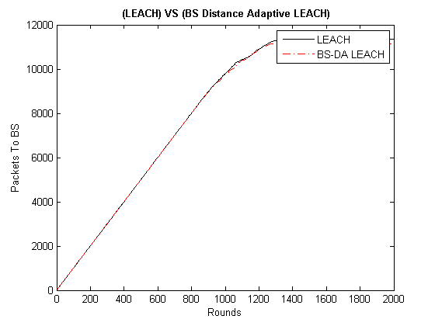
الشكل (15) عدد الطرود المُرسلة إلى المحطة الأساسية
نلاحظ أنّ انتاجيةLEACH المُحسّن من حيث عدد الطرود المرسلة إلى المحطة الأساسية تماثل تقريباً تلك التي في LEACH.
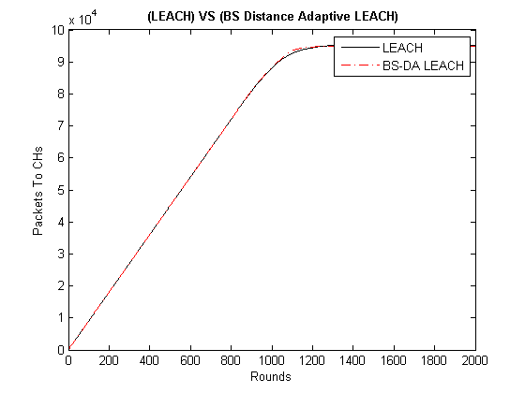
الشكل (16) عدد الطرود المُرسلة إلى رؤوس العناقيد

نلاحظ من الشكل(16) تطابق الإنتاجية من حيث عدد الطرود المُرسلة إلى رؤوس العناقيد في كل من LEACH و LEACH المحسَّن من أجل الحالات التي تكون فيها المحطة الأساسية خارج حقل العمل.

    - عدد رؤوس العناقيد في كل جولة:
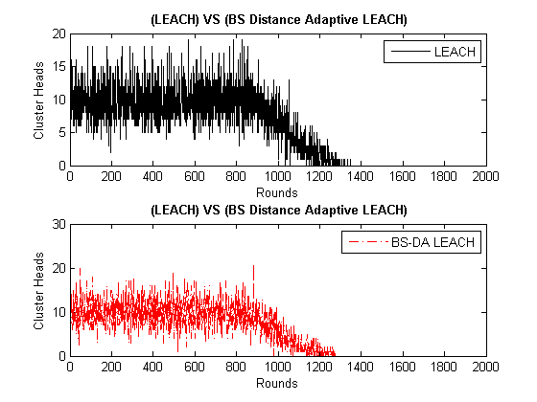
الشكل (17) عدد رؤوس العناقيد بكل جولة
نلاحظ من الشكل(17) تطابق عدد رؤوس العناقيد تقريباً في كل جولة من أجل كلاً من LEACH و LEACH المحسّن.
5. الخلاصة:
قام بروتوكول LEACH المُتكيِّف مع البعد عن المحطة الأساسية (LEACH المُحسّن) بالتحسين على مقياسين مهمين جداً من مقاييس الأداء وهما (فترة الاستقرار وفترة عدم الاستقرار), حيث أعطى هذا البروتوكول فترة استقرار أكبر وفترة عدم استقرار أصغر وذلك في حال توضُّع المحطة الأساسية ضمن حقل العمل, أما في حالة توضُّع المحطة الأساسية خارج حقل العمل فتعطي أداء مماثل تقريباً لأداء خوارزمية LEACH.
- المراجع:
- A. Al-Hilal, S. Dowaji. “Evaluation of WSN hierarchical routing protocols according to energy efficiency heterogeneity levels”, International Review on Computers and Software (I.RE.CO.S), Vol. 8, N. 5, May 2013.
- I.F. Akyildiz, W. Su, Y. Sankarasubramaniam, E.Cayirci. “Wireless sensor networks: a survey”,Computer Networks 38 (2002): 393–422, 2001.
- K.Akkaya, M.Younis. “A survey on routing protocols for wireless sensor networks”, Ad Hoc Networks 3 (2005) :325-349, September 2003.
- Al-Karaki, Jamal N. “Routing Techniques in Wireless Sensor Networks: A Survey”, Wireless Communications, IEEE , 6-28 , Dec. 2004
- W. R. Heinzelman, A. P. Chandrakasan, and H. Balakrishnan. “An application-specific protocol architecture for wireless microsensor networks ”, IEEE Transactions on Wireless Communications, 1(4):660–670, October 2002.
- Li Qing, Qingxin Zhu, Mingwen Wang. “Design of distributed energy-efficient clustering algorithm for heterogeneous wireless sensor networks” Computer Communications 29, 2230–2237, 2006.
- G. Smaragdakis, I. Matta, A. Bestavros, “SEP: A Stable Election Protocol for clustered heterogeneous wireless sensor networks,” Second International Workshop on Sensor and Actor Network Protocols and Applications (SANPA 2004), 2004.
- S. Lindsey and C. Raghavendra, “PEGASIS: Power-Efficient Gathering in Sensor Information Systems,” Proceedings of IEEE Aerospace Conference, 1125-1130, Montana, USA, Mar. 2002.

- مسرد المصطلحات:
المصلح العربي | المعنى الإنكليزي
شبكة الحساسات اللاسلكية | Wireless sensor network
المحطة الأساسية أو المصرف | Base Station or Sink node
LEACH المحسّن | Base station distance adaptive LEACH
فترة عدم الاستقرار | Instability period
فترة الاستقرار | Stability period
دورة حياة الشبكة | Network lifetime
نشر عقد الشبكة | Network deployment
النموذج الراديوي | Radio model
تغذية راجعة | Feedback
معدل طاقة الشبكة المقدّرة | Estimated average energy
العقد الرأسية | Cluster Heads (CH)
العقد غير الرأسية | Non-Cluster Head Nodes(Normal Node)
التوجيه المسطّح | Flat routing
التوجيه الهرمي | Hierarchical routing
التوجيه المعتمد على موقع العقد | Location based routing
التوجيه المعتمد على جودة الخدمة | QOS based routing
برمترات المحاكاة | Simulation parameters

